Koneru Lakshmaiah Education Foundation
(Deemed to be University estd. u/s. 3 of the UGC Act, 1956)
Off-Campus: Bachupally-Gandimaisamma Road, Bowrampet, Hyderabad, Telangana - 500 043
“Job Portal with Resume Parsing & Matching”
(HireSphere – Integrated Job Portal & Resume Intelligence)
A Project Report Submitted in the partial fulfillment of the requirements for the award of the degree of
BACHELOR OF TECHNOLOGY
In
CSE
By
M. MOHANA ASMITHA 2520030486
G. LAASYA 2520030118
CH. NOHITHA 2520030130
Course: DATABASE SYSTEMS ENGINEERING AND DISTRIBUTED BACKEND DEVELOPMENT (25CS1302E)
Section 07 | Team 13 | Y25 – 2026-2027, Trimester 4
Under the Esteemed Guidance of
Course Instructor & Guide: Dr. D. Ramya Krishna
Course Coordinator: Dr. R. Sateesh Kumar
CSE

K L (Deemed to be) University
[DEPARTMENT NAME]
Declaration
The Project Report entitled “Job Portal with Resume Parsing & Matching” is a record of bonafide work of M. MOHANA ASMITHA – 2520030486, G. LAASYA – 2520030118 and CH. NOHITHA – 2520030130, submitted in partial fulfillment of the requirements of the course DATABASE SYSTEMS ENGINEERING AND DISTRIBUTED BACKEND DEVELOPMENT (25CS1302E), Section 07, Team 13, during 2026–2027, Trimester 4, at KLH University. The results embodied in this report have not been copied from any other student, department, or institution.

M. MOHANA ASMITHA – 2520030486
G. LAASYA – 2520030118
CH. NOHITHA – 2520030130

K L (Deemed to be) University
[DEPARTMENT NAME]
CERTIFICATE
This is to certify that the project report entitled “Job Portal with Resume Parsing & Matching” is a bonafide work done and submitted by M. MOHANA ASMITHA – 2520030486, G. LAASYA – 2520030118, CH. NOHITHA – 2520030130 in partial fulfillment of the requirements of the course DATABASE SYSTEMS ENGINEERING AND DISTRIBUTED BACKEND DEVELOPMENT (25CS1302E), Section 07, Team 13, at KLH University during 2026–2027, Trimester 4.

Signature of the Guide

Signature of the Course Coordinator | Signature of the HOD

ACKNOWLEDGEMENT
The success of this project would not have been possible without the timely help and guidance of many people. We wish to express our sincere thanks to everyone who assisted us, in one way or another, in completing this project.
We express our greatest appreciation to our Course Coordinator [Dr. R. Sateesh Kumar] and our guide [D. Ramya Krishna], [CSE], for their tremendous support, encouragement and guidance throughout this project.
We express our gratitude to [Dr. P Venkateswar rao], Head of the Department, for providing us with the facilities, ways and means by which we were able to complete this project-based lab.
We thank all the members of the teaching and non-teaching staff who have assisted us directly or indirectly in the successful completion of this project. Finally, we sincerely thank our parents, friends and classmates for their kind help and cooperation during our work.

M. MOHANA ASMITHA – 2520030486
G. LAASYA – 2520030118
CH. NOHITHA – 2520030130

ABSTRACT
The Job Portal with Resume Parsing & Matching (HireSphere) is a database-driven web application designed to simplify and improve the recruitment process for job seekers and recruiters. Job seekers can create accounts and profiles, upload or build resumes, search and filter job opportunities, and apply to suitable positions. Recruiters can create company-linked accounts, post and manage job vacancies, review applications, and discover suitable candidates from a talent pool.
A key feature of the system is resume parsing, which extracts contact details, online profile links, a skill inventory and a professional summary from an uploaded resume (PDF, DOCX, TXT, JSON or Markdown), computes an ATS (Applicant Tracking System) readability score, and audits the resume for critical issues, warnings and strengths. The system then compares candidate profiles with job requirements using a weighted matching algorithm — skills (65%), experience (25%) and education (10%) — and generates a compatibility score and a verdict (Strong Fit, Worthy Candidate, Moderate Fit or High Gap), together with the list of matched and missing skills.
The project applies Database Systems Engineering concepts: relational schema design with primary keys, unique constraints and indexes, SQL queries, ACID transactions (application submission, withdrawal and job deletion each run as a single atomic unit), and a hybrid relational/JSON storage model. For distributed backend development, the system is organised as a layered REST architecture — a React single-page frontend communicating over JSON/HTTP with an Express.js API that is divided into authentication, user, job, application, talent-matching and resume-enhancement modules, secured with JWT authentication, bcrypt password hashing, role-based access control, schema validation (zod), rate limiting and secure HTTP headers. An optional server-side integration with the Google Gemini API provides AI-assisted resume enhancement.
The system was verified by running the backend against a freshly seeded SQLite database and executing 37 scripted API assertions, all of which passed, along with direct tests of the matching engine and resume parser. The proposed system reduces manual resume screening, provides personalised job recommendations, helps recruiters identify suitable candidates quickly, and improves the overall efficiency of the recruitment process.
Keywords: Job Portal, Resume Parsing, Candidate Matching, ATS Score, REST API, JWT, SQLite, React, Express.js.

INDEX
S.No. | Chapters | Topics | Page No.
 | Acknowledgement |  | 4
 | Abstract |  | 5
1 | Introduction | 1.1 Background of the Project; 1.2 Problem Statement; 1.3 Scope; 1.4 Objectives; 1.5 Importance; 1.6 Target Users | 7
2 | System Requirements | 2.1 Hardware; 2.2 Software; 2.3 Development Tools and Frameworks | 9
3 | Technology Stack | 3.1 Frontend; 3.2 Backend; 3.3 Database; 3.4 Version Control; 3.5 Authentication and Security Libraries; 3.6 Proposed vs Implemented Stack | 10
4 | System Architecture | 4.1 High-Level Architecture Diagram; 4.2 Description of Each Layer; 4.3 Deployment Architecture | 12
5 | Design | 5.1 Database Design Principles; 5.2 ER Diagram / Database Schema; 5.3 Design Decisions and Assumptions | 13
6 | Implementation | 6.1 Module-wise Implementation; 6.2 Front-end Logic; 6.3 API Integration; 6.4 Authentication and Authorization | 15
7 | Features | 7.1 List of Main Features; 7.2 How Each Feature Works | 18
8 | Testing | 8.1 API Testing; 8.2 Integration Testing; 8.3 Tools Used; 8.4 Test Cases and Results | 19
9 | Deployment | 9.1 Steps to Deploy; 9.2 Environment Configuration; 9.3 Hosting of Frontend and Backend | 21
10 | Challenges & Limitations | 10.1 Issues Identified; 10.2 Solutions Applied; 10.3 Current Limitations or Known Bugs | 22
11 | Future Enhancements | 11.1 Planned Features; 11.2 Possible Integrations or Optimizations | 24
12 | Conclusion | 12.1 Summary; 12.2 What Was Achieved; 12.3 Skills Learned | 25
13 | References | Documentation, tools and resources used | 26
14 | Appendices | A Sample Code; B Setup Instructions; C Default Login Credentials; D API Reference; E Screenshots; F Database and Backend Screenshots | 27

CHAPTER 1: INTRODUCTION

1.1 Background of the Project
Recruitment today is a high-volume, document-heavy activity. A single job opening can attract hundreds of resumes in different formats, and recruiters must read each one to decide who deserves an interview. Job seekers face the opposite problem: thousands of vacancies are spread across portals, and it is hard to tell which of them genuinely fit their skills. In many organisations, screening is still done manually — by reading resumes one at a time and keeping notes in spreadsheets — which is slow, inconsistent and prone to overlooking good candidates.
The Job Portal with Resume Parsing & Matching, named HireSphere, replaces this manual coordination with a single database-backed platform. Candidate profiles, job postings and applications are stored in one database; resumes are converted into structured data; and the system itself computes how well a candidate fits a job, rather than leaving that judgement to a recruiter reading raw documents.

1.2 Problem Statement
Given a growing pool of job seekers with differently formatted resumes and a stream of job vacancies posted by different recruiters, the system must answer three questions reliably: (1) which jobs best suit a particular candidate, (2) which candidates best suit a particular job, and (3) whether a candidate's resume is well-formed enough to be read correctly by an ATS. Answering these questions manually does not scale, is error-prone, and gives job seekers no feedback on why they were or were not a good fit.

1.3 Scope of the Project
The system covers the lifecycle of a job application from both sides of the market:
- Job seekers: register and log in, maintain a profile, search and filter jobs, see jobs ranked by personal match score, apply with a cover note, track application status, withdraw an application, parse an uploaded resume, receive an ATS audit, and build a formatted resume.
- Recruiters: register with company details, post, edit and delete job vacancies, review applications ranked by match score, move each application through the hiring pipeline, and browse a talent pool ranked against any selected job.
- Platform: JWT-based authentication, role-based authorisation, persistent storage, atomic multi-step operations and an optional AI-assisted resume enhancement service.
Payment processing, in-app messaging, video interviews, email notification, multi-tenant company administration and a native mobile application are outside the scope of this submission.

1.4 Objectives
- Extract structured information (contact details, links, skills, summary) from resumes uploaded in common file formats.
- Compute a transparent, explainable compatibility score between a candidate and a job, listing matched and missing skills.
- Provide job seekers with personalised job recommendations and recruiters with ranked candidate lists.
- Prevent duplicate applications to the same job and keep the applicant count consistent using database transactions.
- Secure the system with role-based access so that job seekers can never reach recruiter-only functionality, and recruiters can only modify their own postings.
- Demonstrate relational database design, indexing, SQL and transaction management together with a modular REST backend.

1.5 Importance of the Application
By converting unstructured resumes into structured, comparable data, the system reduces the time recruiters spend on first-round screening and makes the shortlisting criteria visible and consistent. Job seekers benefit from immediate feedback: they can see which of a job's required skills they already have, which are missing, and how their resume scores against ATS-style checks, before they apply.

1.6 Target Users / Audience
The system serves two roles. Job seekers (students, fresh graduates and professionals) use it to find jobs, apply, and improve their resumes. Recruiters (hiring managers and talent-acquisition staff) use it to publish vacancies, evaluate applicants and move them through the hiring stages.

CHAPTER 2: SYSTEM REQUIREMENTS

2.1 Hardware Requirements
The application is lightweight. SQLite is an embedded database, so no separate database server is required. A development or demonstration machine with a dual-core processor, 4 GB of RAM and roughly 500 MB of free disk space (for Node modules, the database file and project source) is sufficient to run the complete stack — frontend, backend and database — on one computer.

2.2 Software Requirements
- Node.js 18 or later (20+ recommended) with npm
- A modern web browser (Chrome, Edge or Firefox)
- Git, for version control
- Visual Studio Code (recommended editor); a SQLite viewer such as DB Browser for SQLite (optional) to inspect the database
- A Google Gemini API key (optional) — only required for the AI resume-enhancement endpoint

2.3 Development Tools and Frameworks
The frontend was built with React 19 and TypeScript, bundled with Vite and styled with Tailwind CSS. The backend is a Node.js REST API built with Express.js and TypeScript (executed with tsx). Data is stored in SQLite through the better-sqlite3 driver. Request validation uses zod, authentication uses JSON Web Tokens and bcrypt, and the optional AI feature uses the official @google/genai SDK. Git and GitHub were used for source control and Visual Studio Code as the primary development environment.

CHAPTER 3: TECHNOLOGY STACK
Layer | Technology | Purpose
Frontend | React 19, TypeScript 5.8, Vite 6 | Single-page application and build tooling
Styling / UI | Tailwind CSS 4, lucide-react, motion | Responsive styling, icons, animation
Documents | jsPDF; browser print | Resume download / PDF export
Backend | Node.js, Express 4, tsx | REST API and TypeScript execution
Validation | zod 4 | Request-body schemas
Database | SQLite via better-sqlite3 (WAL mode) | Persistent relational storage with transactions
Security | bcryptjs, jsonwebtoken, helmet, cors, express-rate-limit | Hashing, tokens, headers, CORS, throttling
AI (optional) | @google/genai (Gemini 2.5 Flash) | Resume enhancement and ATS suggestions

3.1 Frontend
The frontend is a single-page application written in React 19 with TypeScript and bundled by Vite. Tailwind CSS provides utility-first styling, lucide-react supplies icons, and motion adds light animation. The interface is organised into five top-level tabs — Jobs, Recruiter Portal, Resume Builder, Resume Parser and Profile — with modal dialogs for authentication, job application and profile editing. Resume export uses jsPDF and the browser's print-to-PDF facility.

3.2 Backend
The backend is a REST API built with Node.js and Express.js in TypeScript. Code is organised into a database module (db.ts), an authentication module (auth.ts) and six route modules — auth/users, jobs, applications, talent and resume — each declaring its URLs, the roles allowed to call them and the validation and business rules that apply. The candidate–job scoring engine is a pure TypeScript function shared between frontend and backend, so the same score is shown in the browser and stored by the server.

3.3 Database
SQLite, accessed through the synchronous better-sqlite3 driver, stores all persistent data in three tables — users, jobs and applications. The database runs in WAL (write-ahead logging) mode for better concurrent read performance. Each table holds its identifying and query-critical attributes (id, email, role, recruiter_id, job_id, candidate_id) as real columns with PRIMARY KEY, UNIQUE, NOT NULL and index definitions, while the remaining profile or posting attributes are stored as a JSON document in a data column. This hybrid design combines relational constraints with schema flexibility for rapidly evolving profile fields.

3.4 Version Control
Git was used for version control, with the project maintained as a GitHub repository. The frontend and backend source are packaged as hiresphere.zip and hiresphere-backend.zip; the backend imports the shared types and matching engine from the frontend's src folder, so the two are merged into a single project directory when run (see Chapter 9).

3.5 Authentication and Security Libraries
Passwords are hashed with bcryptjs (10 salt rounds) before storage; plain-text passwords are never written to the database. Sessions are stateless JSON Web Tokens signed with a server-side secret (JWT_SECRET), valid for 7 days, and carrying only the user's id, email and role. Express middleware verifies the token on protected routes and enforces role-based access. helmet sets secure HTTP headers, cors restricts cross-origin access (configurable through CORS_ORIGIN), express-rate-limit throttles the authentication endpoints to 50 requests per 15 minutes per client, and the JSON body size is limited to 2 MB. In production mode the server refuses to start without an explicit JWT_SECRET.

3.6 Proposed vs Implemented Stack
The project abstract proposed a broader technology set. The table below records how each item stands in the submitted implementation, so that the report accurately reflects what was built.
Proposed in abstract | Status in this submission
PostgreSQL with pgvector (relational + vector search) | Replaced by SQLite (embedded). Matching uses weighted skill overlap rather than vector similarity. Migration to PostgreSQL/pgvector is planned (Ch. 11).
MongoDB for document data | Document-style data is stored as JSON in SQLite data columns.
Python FastAPI, Pydantic, SQLAlchemy | Replaced by Node.js/Express with zod validation and better-sqlite3.
JWT and OAuth2 | JWT implemented; OAuth2 social login is not implemented.
Separate microservices (Express, Spring Boot) | Implemented as one modular Express service with separate route modules per domain (user, job, application, matching, resume).
Redis, Docker, Kubernetes, GitHub Actions | Not implemented; planned as future work.
OpenTelemetry, Prometheus, Grafana | Not implemented; a /api/health endpoint is provided as a basic liveness check.
Postman, Pytest | Testing was performed with scripted HTTP tests and direct function tests (Ch. 8); the endpoint table in Appendix D can be imported into Postman.

CHAPTER 4: SYSTEM ARCHITECTURE

4.1 High-Level Architecture Diagram
HireSphere follows a three-tier architecture that separates the user interface, the business logic and the persisted data. Figure 4.1 shows the layers and the way a request flows between them.
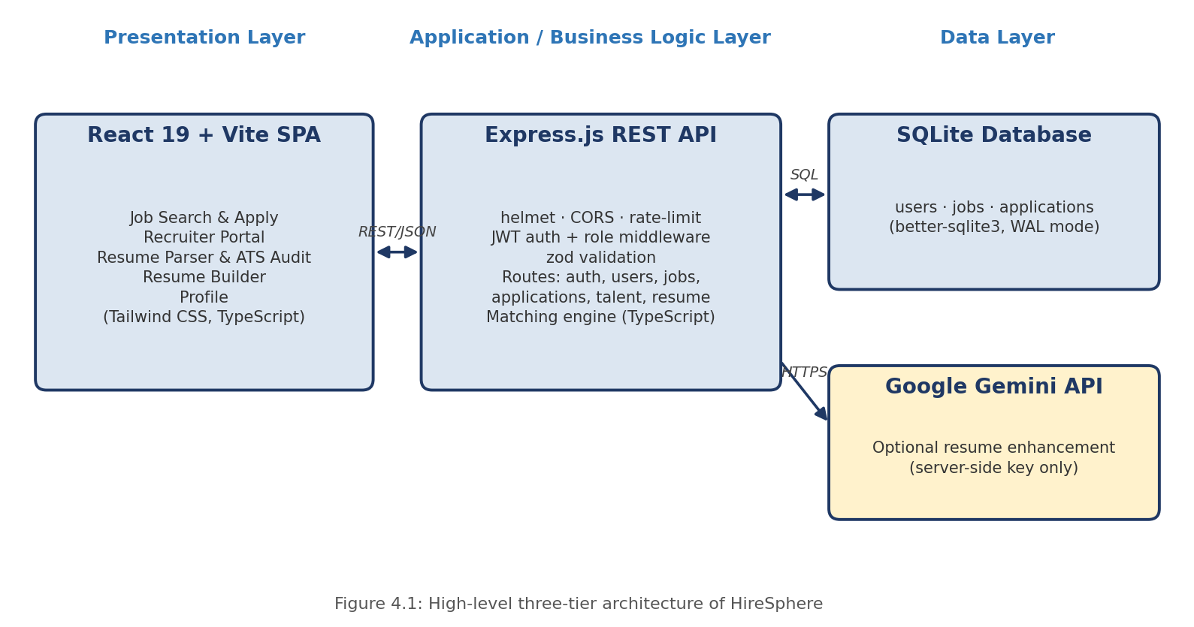

4.2 Description of Each Layer
Presentation layer. The React single-page application never accesses the database directly. All persistent data is obtained by calling the REST API over HTTP; a small client module (api.ts) wraps every endpoint, attaches the JWT as a Bearer token and converts error responses into exceptions. During development, Vite's proxy forwards any request beginning with /api to the Express server, so the browser needs no knowledge of the backend's port.
Application layer. The Express.js API receives each request through security middleware (helmet, CORS, JSON body parser, and rate limiting on /api/auth), then through authentication middleware (requireAuth verifies the JWT and attaches the user) and role middleware (requireRole), before a route handler validates the body with zod and applies business rules — for example, rejecting a duplicate application, checking that a recruiter owns the job being edited, or computing the match score — and finally reads or writes the database. Unknown /api routes return a JSON 404, and unexpected errors return a generic 500 without leaking internals.
Data layer. The SQLite database is accessed through better-sqlite3 prepared statements. Multi-step operations are wrapped in db.transaction() so that they succeed or fail as a whole.
External service. The optional /api/resume/enhance endpoint calls the Google Gemini API from the server, so the API key is never exposed to the browser.

4.3 Deployment Architecture
For development and demonstration, the processes run on a single machine: the Express API on port 4000 and the Vite development server on port 3000 (proxying /api to port 4000). In production mode (NODE_ENV=production), the same Express server also serves the compiled frontend from the dist folder and falls back to index.html for client-side routes, so a single process and a single port deliver the whole application. No containerisation or CI/CD pipeline was configured for this submission; Chapter 11 outlines how it could be extended.

CHAPTER 5: DESIGN

5.1 Database Design Principles
The schema separates the attributes that the system must search, join or constrain from the attributes that are merely displayed. Identity and access fields (user id, email, password hash, role), ownership fields (recruiter_id) and relationship fields (job_id, candidate_id) are stored as ordinary typed columns with PRIMARY KEY, NOT NULL, UNIQUE and index definitions, so that the database itself rejects duplicate emails and duplicate applications even if application code were to attempt them. Descriptive attributes such as skills, education, work history and job requirements are stored as a JSON document in a data column, which keeps the schema stable while profile fields evolve.

5.2 ER Diagram / Database Schema
The database consists of three related tables, shown in Figure 5.1.
Table | Column(s) | Constraints / Index | Description
users | id, email, password_hash, role, data | PK(id); email UNIQUE NOT NULL; password_hash, role NOT NULL | Every account (jobseeker or recruiter). data holds the JSON profile: name, phone, location, skills, education, work history, certifications, links, company details.
jobs | id, recruiter_id, data | PK(id); INDEX idx_jobs_recruiter(recruiter_id) | Each vacancy owned by a recruiter. data holds title, company, location, type, salary, required skills, category, responsibilities, requirements, applicantsCount.
applications | id, job_id, candidate_id, data | PK(id); UNIQUE(job_id, candidate_id); INDEX idx_apps_candidate(candidate_id) | One application per candidate per job. data holds match score, matched/missing skills, status, cover note and the resume snapshot.

The relationships are users (recruiter) 1:M jobs, users (job seeker) 1:M applications, and jobs 1:M applications. The composite UNIQUE(job_id, candidate_id) constraint guarantees that a candidate can apply to a given job only once.

5.3 Design Decisions and Assumptions
- Hybrid relational + JSON storage. Keys, ownership and uniqueness are enforced with real columns; evolving profile and job attributes live in JSON. This avoids a very wide schema and a migration for every new profile field, at the cost of not being able to index or constrain individual JSON attributes. Searching by keyword is therefore performed in the API layer over the parsed documents.
- Application snapshot. Each application stores a copy of the job title, company, candidate contact details and the resume used. This keeps an application record meaningful even if the profile or job is later edited, trading some redundancy for historical accuracy.
- Server-side scoring. The match score is computed by the server when the candidate applies, using the shared matching engine, so a client cannot submit a forged score.
- Maintained counter. The applicantsCount of a job is updated in the same transaction as the application insert or delete, so the counter cannot drift from the real number of applications.
- Reference integrity in code. job_id, candidate_id and recruiter_id behave as foreign keys but are not declared with FOREIGN KEY constraints; referential integrity (for example deleting a job's applications when the job is deleted) is enforced inside transactions in the route handlers. Declaring explicit foreign keys is listed as a future improvement.
- Roles. Registration creates only jobseeker or recruiter accounts. Legacy accounts with the role candidate are treated as job seekers.

CHAPTER 6: IMPLEMENTATION

6.1 Module-wise Implementation
The backend is divided into modules, each with its own route file:
Module | File | Responsibility
Authentication | routes/auth.ts (authRouter) | Signup, login, current user. Hashes passwords, issues JWT.
Users | routes/auth.ts (usersRouter) | Update own profile; change password (verifies current password).
Jobs | routes/jobs.ts | Public search/list/detail; recruiter create, update, delete own postings.
Applications | routes/applications.ts | Apply (with server-side score), list mine, recruiter pipeline, status update, withdraw.
Talent | routes/talent.ts | Recruiter-only talent pool, optionally ranked against a job.
Resume | routes/resume.ts | Optional AI enhancement via Gemini (server-side key).
Shared | auth.ts, db.ts, matchingEngine.ts | JWT helpers and role middleware; schema creation; scoring.

6.1.1 Resume parsing pipeline
The Resume Parser module (resumeParser.ts and the ResumeParser component) turns a resume file into a structured ParsedResume object:
- Text extraction. extractTextFromAnyFile reads the uploaded file. TXT, MD, RTF and CSV are read as text; JSON is pretty-printed; PDF and DOCX are processed by lightweight in-browser extractors. A pasted raw-text option is also provided.
- Entity extraction. Regular expressions extract the email address, phone number and LinkedIn/GitHub links; the candidate name is taken from the first suitable header line; the summary is taken from the lines following a “Summary/Objective/Profile” heading.
- Skill detection. The text is matched against a dictionary of about 45 technical skills (languages, frameworks, databases, cloud and DevOps tools) and 9 soft skills.
- ATS scoring. A base score of 70 is raised for skill-keyword density (6 or more technical skills), strong action verbs (3 or more) and the presence of LinkedIn/GitHub links, capped at 98.
- Quality audit. auditResumeContent checks contact details, summary length (20+ words), keyword density (5+ skills) and quantified achievements, and returns lists of critical issues, warnings and strengths, each with a recommendation.
- Output. The parsed data can be set as the active resume for applications, synchronised into the candidate's profile, auto-improved for ATS, and downloaded as formatted text, JSON, or print/PDF.
6.1.2 Candidate–job matching algorithm
The matching engine (evaluateCandidateForJob) compares a candidate — either a stored profile or a parsed resume — with a job. Skill names are normalised by lower-casing and stripping non-alphanumeric characters, and a required skill counts as matched if it equals, contains or is contained in any candidate skill. The final score combines three components:
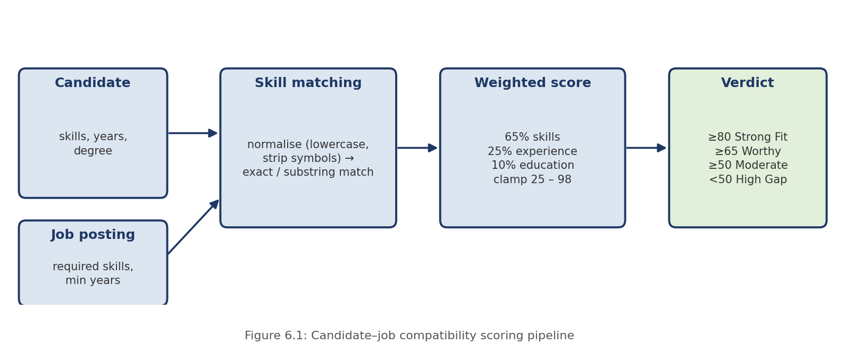
Score = round( 65 × skillRatio + 25 × expRatio + 10 × eduFactor ), clamped to the range 25–98, where skillRatio = matched skills ÷ required skills; expRatio = (candidate years + 0.5) ÷ job minimum years, limited to the range 0.3–1; and eduFactor = 1.0 if the candidate's degree mentions technology, science or engineering, otherwise 0.8. A score of 80 or more is a Strong Fit, 65–79 a Worthy Candidate, 50–64 a Moderate Fit and below 50 a High Gap; the first two verdicts mark the candidate as “worthy”. The engine also returns the matched and missing skills and plain-English reasons such as the experience comparison.
Worked example. For a job requiring Python, FastAPI, PostgreSQL and Docker with a 2-year minimum, a candidate with Python and Docker, 1 year of experience and a B.Com degree gets skillRatio = 0.5 (32.5 points), expRatio = 1.5 ÷ 2 = 0.75 (18.75 points) and eduFactor = 0.8 (8 points): the total is 59.25, rounded to 59 – Moderate Fit, with FastAPI and PostgreSQL reported as missing skills.
6.1.3 Application workflow and transactions
When a job seeker applies, the server (1) validates the body with zod, (2) loads the job and the applicant, (3) rejects the request with 409 if an application for the same job and candidate already exists, (4) computes the match score, and (5) inside one database transaction inserts the application and increments the job's applicantsCount. Withdrawing an application and deleting a job use the same pattern: the application row (or all of the job's application rows) and the counter are changed atomically. Application statuses are Applied, Under Review, Shortlisted, Interview Scheduled, Offered and Rejected.

6.2 Front-end Logic
The root App component owns the shared application state — the current user, registered users, job catalogue, applications and the active parsed resume — and passes it down to the five tab components. In the standalone frontend build included in hiresphere.zip, this state is persisted in the browser's localStorage (keys such as hiresphere_active_user, hiresphere_jobs and hiresphere_applications), seeded from bundled sample data, which allows the whole interface to be demonstrated without a server. Redux was not used because component-level state and props were sufficient at this scale. Shared components — AuthModal, ApplyModal, ProfileEditorModal and the Navbar — are written once and reused across tabs. After login or signup, a profile-review dialog prompts users to confirm their details, which improves the quality of the data used for matching.

6.3 API Integration
The backend package includes api.ts, a typed client that exposes one function per endpoint (signup, login, me, updateProfile, jobs, myJobs, createJob, updateJob, deleteJob, apply, myApplications, recruiterApplications, setStatus, withdraw, talent and enhanceResume). It stores the JWT under the key hiresphere_token, adds the Authorization header to each request, and throws an Error carrying the server's message when a response is not successful. Because the frontend and API share TypeScript types (UserProfile, Job, JobApplication, CandidateEvaluation), the contract between them is checked at compile time.

6.4 Authentication and Authorization
Signup always creates a jobseeker or recruiter account; the role is validated against an enumeration, and protected fields (id, email, role, password, createdAt) are stripped from any profile data supplied by the client, which prevents mass-assignment attacks such as injecting a different role or id. Login compares the supplied password with the stored bcrypt hash and returns a JWT. Every protected route runs requireAuth, and role-specific routes additionally run requireRole('recruiter') or requireRole('seeker'), returning 403 Forbidden for the wrong role. Ownership is checked separately: a recruiter may edit, delete or change the application status only for jobs they posted.
Access level | Endpoints
Public | GET /api/health; POST /api/auth/signup; POST /api/auth/login; GET /api/jobs; GET /api/jobs/:id
Any logged-in user | GET /api/auth/me; PUT /api/users/me; PUT /api/users/me/password; POST /api/resume/enhance
Job seeker only | POST /api/applications; GET /api/applications/mine; DELETE /api/applications/:id
Recruiter only | GET /api/jobs/mine; POST, PUT, DELETE /api/jobs; GET /api/applications/recruiter; PATCH /api/applications/:id/status; GET /api/talent

CHAPTER 7: FEATURES

7.1 List of Main Features
Job seeker features:
- Register and log in; review and edit a detailed profile (skills, education, work history, certifications, links, expected salary)
- Search jobs by keyword; filter by category and job type; toggle ranking by personal match score
- See a match score and matched/missing skills for each job before applying
- Apply with a cover note and the active resume; track the application status; withdraw an application
- Upload a resume (PDF, DOCX, TXT, JSON, MD) or paste text, and receive parsed data, an ATS score and a quality audit
- Auto-optimise a resume for ATS and download it as text, JSON or PDF
- Build a resume with four templates (Modern, Minimal, Executive, Tech-ATS) with a live ATS audit
Recruiter features:
- Register with company details; post new vacancies with required skills and experience
- View applications for each job, ranked by match score, with matched/missing skills and the candidate's resume
- Update application status through the six-stage hiring pipeline
- Browse the talent pool and rank all registered job seekers against a selected job

7.2 How Each Feature Works
Job search and recommendation. The job list can be filtered by free-text query (matched against title, company, description and skills), category, type and location. With “sort by match” enabled, every job is scored against the logged-in user's profile by the matching engine and the list is sorted from best to worst fit, which serves as the personalised recommendation.
Apply. The Apply dialog shows the candidate's evaluation and collects a cover note; the server recomputes the score, rejects duplicates and stores the application.
Recruiter pipeline. The recruiter selects one of their jobs and sees its applications sorted by match score. Changing a status calls PATCH /api/applications/:id/status, which verifies that the recruiter owns the job. The talent-pool tab lists job seekers and, for the selected job, evaluates each one and orders them by score with a verdict label.
Resume parsing and audit. See Section 6.1.1. After parsing, the “auto-fix” action adds action verbs, metrics and common skill keywords, and the result can be set as the active resume and synchronised to the profile. The resume builder offers four templates with a live ATS score and print/PDF export.
AI enhancement (optional). When GEMINI_API_KEY is set on the server, POST /api/resume/enhance sends the resume text and an optional target role to Gemini 2.5 Flash and returns an ATS score, feedback, an improved summary, suggested skills and rewritten bullets. Without a key it responds 501; on provider failure, 502.

CHAPTER 8: TESTING

8.1 API Testing
The backend was tested by starting the real Express server against a freshly created and seeded SQLite database (npm run seed produced 5 users, 24 jobs and 5 applications) and driving every endpoint family with a scripted HTTP client. The script performed 37 individual assertions covering authentication, authorisation, validation, ownership checks, duplicate prevention, ranking and transactional counters, and all 37 passed. Each assertion checks the exact HTTP status code, and several also check the response content (for example the sorted order of ranked results).

8.2 Integration Testing
Testing was end-to-end against a real database rather than mocked data: tokens obtained from the login endpoint were used to call protected routes, a job created by one recruiter was applied to by job seekers, listed and updated by the recruiter, and finally deleted, verifying at each step that the data persisted in SQLite and that the applicant counter stayed consistent. The matching engine and resume parser were additionally exercised directly with controlled inputs (Section 8.4).

8.3 Tools Used for Testing
- Scripted HTTP tests (Python standard library) — full-workflow API verification
- tsx — direct execution of the matching engine and resume parser functions
- SQLite queries — verification of seeded row counts and persisted data
- The endpoint list in Appendix D can be imported into Postman or a similar client for manual exploration

8.4 Test Cases and Results
A representative set of API test cases is summarised below (the 27 rows group the 37 assertions).
# | Test Case | Expected Result | Actual
1 | GET /api/health | 200 OK | Pass
2 | Login with wrong password | 401, login rejected | Pass
3 | Login with seeded job seeker and recruiter | 200 + JWT | Pass
4 | Call protected route without token | 401 Unauthorized | Pass
5 | Signup with an invalid email | 400 Bad Request | Pass
6 | Signup with injected role and id in profile data | 201; role and id taken from server, injected values ignored | Pass
7 | Signup again with same email in different letter case | 409 Conflict | Pass
8 | Job seeker tries to post a job | 403 Forbidden | Pass
9 | Recruiter posts a job with an empty title | 400 Bad Request | Pass
10 | Recruiter posts a valid job | 201 Created | Pass
11 | Search jobs with q=postgresql | 200; 7 matching jobs returned | Pass
12 | Get a non-existent job | 404 Not Found | Pass
13 | A different recruiter edits someone else's job | 403 “Not your job posting” | Pass
14 | Job seeker applies to a job | 201; matchScore, matched and missing skills returned | Pass
15 | Apply to the same job twice | 409 “You already applied” | Pass
16 | Recruiter tries to apply to a job | 403 Forbidden | Pass
17 | Apply to a non-existent job | 404 Not Found | Pass
18 | Recruiter lists applications for a job | 200; sorted by score descending (98, 86) | Pass
19 | Update status with an invalid value | 400 with allowed statuses | Pass
20 | Another recruiter / a job seeker changes status | 403 Forbidden | Pass
21 | Job seeker views talent pool | 403 Forbidden | Pass
22 | Recruiter ranks talent pool against a job | 200; candidates ordered by evaluation score | Pass
23 | Withdraw an application | 200; applicantsCount reduced from 2 to 1 | Pass
24 | Change password with wrong current password / correct password | 401 / 200; login works with the new password | Pass
25 | Update profile including role and email fields | 200; role and email unchanged | Pass
26 | Enhance resume without GEMINI_API_KEY | 501 Not Implemented | Pass
27 | Delete a job, then fetch it; unknown /api route | 200, then 404; 404 | Pass

Matching engine tests
Job: Python, FastAPI, PostgreSQL, Docker; minimum experience 2 years.
Candidate | Matched / Missing skills | Score | Verdict
All 4 skills, 3 yrs, B.Tech Computer Science | 4 / 0 | 98 | Strong Fit
“postgres”, “py”, 2 yrs, B.Tech | Python, PostgreSQL / FastAPI, Docker | 68 | Worthy Candidate
Python, Docker, 1 yr, B.Com | 2 / 2 | 59 | Moderate Fit
Python only, 0 yrs, BA | 1 / 3 | 32 | High Gap
No relevant skills | 0 / 4 | 25 (floor) | High Gap

The scores follow the documented formula exactly, the lower bound of 25 and upper bound of 98 are respected, and the normalisation allows an alias such as “postgres” to match “PostgreSQL”.
Defects found during testing
- Partial job update resets omitted fields (backend). A PUT /api/jobs/:id request containing only {"title":"T2"} returned a job whose skills, type, category, salary and minimum experience had been reset to schema defaults ([], Full-Time, General, empty, 0). The cause is that the update schema is built with jobBody.partial(), which in zod 4 still applies the .default() values of omitted fields. Because the match score depends on the job's skills, this silently distorts later scores. It is recorded in Chapter 10 with the recommended fix.
- Resume parser fallbacks (frontend). When parsing a sample resume, the skills, e-mail, links and summary were extracted correctly, but the phone number “+91 98765 12345” was replaced by a placeholder value, and the experience, education, location, projects and certifications sections were filled from built-in default content rather than from the resume text. This is described under limitations in Chapter 10.

CHAPTER 9: DEPLOYMENT

9.1 Steps to Deploy
Because the backend imports the shared types, matching engine and seed data from the frontend's src folder, the two packages are combined in one directory:
- Extract hiresphere.zip into a project folder, then extract hiresphere-backend.zip into the same folder, allowing its files (server/, api.ts, package.json, vite.config.ts) to overwrite the frontend's copies.
- Install dependencies: npm install
- Copy .env.example to .env and set PORT, JWT_SECRET and DB_PATH (and, optionally, GEMINI_API_KEY).
- Create and seed the database: npm run seed
- Start the API and the frontend together: npm run dev:all (API on port 4000, frontend on port 3000).
- Open http://localhost:3000 and log in with a seeded account (Appendix C).
For a single-process production run: npm run build, then npm start (NODE_ENV=production). The Express server serves the compiled frontend from dist and the API on one port.
The standalone frontend (hiresphere.zip alone) can be run with npm install and npm run dev; it uses bundled sample data and localStorage and does not need the backend.

9.2 Environment Configuration
Server configuration is read from a .env file (not committed to version control); .env.example documents the variables with placeholder values.
Variable | Purpose
PORT | Port the API listens on (default 4000)
JWT_SECRET | Secret used to sign tokens. Mandatory in production; a development fallback is used otherwise
DB_PATH | SQLite database file (default hiresphere.db)
CORS_ORIGIN | Comma-separated allowed origins (default: any, for development)
GEMINI_API_KEY | Enables the AI resume-enhancement endpoint (optional)
GEMINI_MODEL | Model name (default gemini-2.5-flash)
NODE_ENV | Set to production to serve the built frontend and enforce JWT_SECRET

9.3 Hosting of Frontend and Backend
For this submission the application runs locally, which is appropriate for development and in-class demonstration. Vite's proxy removes any cross-origin configuration during development. Because the database is a single file and the production server serves both API and frontend, the application can be hosted on any Node.js-capable platform with a persistent disk; a full cloud deployment was not required for this course submission.

CHAPTER 10: CHALLENGES & LIMITATIONS

10.1 Issues Identified
- Choosing a storage model. Resume and profile data has many nested, frequently changing fields (education lists, work history, skill groups), which would need many join tables in a fully normalised schema.
- Keeping derived data consistent. The applicantsCount shown on each job and the unique-application rule could be violated if the application insert and the counter update were done separately or concurrently.
- Trusting the client. A match score or a role sent from the browser cannot be trusted; profile updates could also try to overwrite protected fields such as role or id.
- Unstructured input. Resumes arrive in different formats and layouts, so extraction has to be tolerant of missing sections.
- Partial-update defect. Testing revealed that PUT /api/jobs/:id resets omitted fields to defaults (Section 8.4).

10.2 Solutions Applied
- A hybrid model was adopted: the columns needed for keys, ownership, uniqueness and indexing are relational, while nested attributes are stored as JSON documents.
- Application submission, withdrawal and job deletion each run inside a better-sqlite3 transaction, and UNIQUE(job_id, candidate_id) enforces one application per candidate per job at the database level.
- The server recomputes the match score, takes the role only from the validated signup enumeration, and strips protected fields from profile updates.
- The parser is rule-based and fault-tolerant: unmatched fields fall back to defaults so the interface always receives a complete ParsedResume object, and a quality audit tells the user what is missing.
- Recommended fix for the partial-update defect: build the update schema without defaults, for example by defining jobUpdate = z.object({ ...fields all marked .optional() }) (or calling .removeDefault() on each field before .partial()), so that only the fields actually sent are merged into the stored job.

10.3 Current Limitations or Known Bugs
- Resume parser accuracy. Name, e-mail, links, skills and summary are extracted from the text, but experience, education, location, projects and certifications are currently populated from default content when not recognised, and unusual phone formats can fall back to a placeholder. PDF text extraction is a lightweight heuristic and may fail on scanned or heavily formatted PDFs; DOCX/PDF files are not processed with a dedicated parsing library or OCR. The “auto-fix” action inserts generic metrics and keywords, which a user must review for truthfulness.
- Matching algorithm. Matching is lexical (normalised substring comparison). Short skill names may produce false positives (for example “py” matching “Python”), synonyms are not understood, and experience for a parsed resume is estimated as 1.5 years per listed position. Semantic/vector matching is not implemented.
- Storage. SQLite is suitable for a single-node demonstration but not for horizontal scaling. Foreign keys are not declared, job search filters rows in application memory without pagination, and fields inside the JSON documents are not individually indexed.
- Frontend–backend wiring. The standalone frontend persists data in localStorage; the REST client (api.ts) and API are provided for integration but the supplied frontend screens are not yet switched over to call them.
- Security hardening. The minimum password length is 4 characters, there is no e-mail verification, password-reset or refresh-token flow, and the Helmet content-security policy is disabled for development.
- Operations. No automated test suite, containerisation, CI/CD pipeline or monitoring has been added, and the system has been run only in a local environment.

CHAPTER 11: FUTURE ENHANCEMENTS

11.1 Planned Features
- Connect the React screens to the REST API through api.ts so that all data is shared between users via the backend instead of browser storage.
- Replace the heuristic resume parser with a robust pipeline (dedicated PDF/DOCX libraries, OCR for scanned files and NLP section detection) so that experience, education, projects and certifications are extracted from the resume itself.
- Semantic matching: store resume and job embeddings in PostgreSQL with pgvector and combine vector similarity with the existing weighted score.
- E-mail verification, password reset, refresh tokens and OAuth2 sign-in.
- E-mail or SMS notifications for application status changes and interview invitations.
- A recruiter analytics dashboard (applications per job, conversion through pipeline stages).

11.2 Possible Integrations or Optimizations
- Migrate from SQLite to PostgreSQL, declare FOREIGN KEY constraints and move frequently searched attributes (skills, location, category) into indexed or normalised tables.
- Split the modular monolith into independent services (user, job, resume-processing, matching and application services) communicating through REST APIs, as proposed in the project abstract, with MongoDB for resume documents.
- Cache job-search and recommendation results with Redis.
- Containerise with Docker and Docker Compose; add GitHub Actions CI/CD; consider Kubernetes for orchestration.
- Add observability with OpenTelemetry, Prometheus and Grafana.
- Add an automated test suite (Jest/Vitest and Supertest, or Pytest for Python services) and pagination for list endpoints.

CHAPTER 12: CONCLUSION

12.1 Summary of the Project
This project set out to replace manual resume screening with a single database-driven web application that connects job seekers and recruiters. A React single-page frontend, a modular Express REST API with 18 functional endpoints (plus a health check), a three-table SQLite database and an explainable scoring engine were designed, built and tested.

12.2 What Was Achieved
The finished system provides role-based authentication; job posting, search and personalised ranking; resume parsing with an ATS score and audit; weighted candidate–job matching with matched and missing skills; a recruiter hiring pipeline and ranked talent pool; transactional application handling that prevents duplicates and keeps counters consistent; and an optional AI-assisted resume-enhancement service. It was verified with 37 scripted API assertions against a freshly seeded database, and the testing process also revealed a genuine defect, which has been documented together with a recommended fix, along with the limitations of the current parser.

12.3 Skills Learned
Working on the project gave practical experience in relational schema design, constraints, indexing and transactions; choosing between relational and document storage; designing a secured REST API with JWT, bcrypt, validation and role-based access control; implementing a transparent scoring algorithm; building a React and TypeScript interface with shared types; and testing a backend systematically — including deliberately probing authorisation and validation rules — which is how the partial-update defect was found.

CHAPTER 13: REFERENCES
- React — Official Documentation, https://react.dev
- Vite — Official Documentation, https://vite.dev
- Tailwind CSS — Official Documentation, https://tailwindcss.com/docs
- TypeScript — Handbook, https://www.typescriptlang.org/docs/
- Node.js — Official Documentation, https://nodejs.org/en/docs
- Express.js — Official Documentation, https://expressjs.com
- SQLite — Official Documentation, https://www.sqlite.org/docs.html
- better-sqlite3 — GitHub repository and API documentation, https://github.com/WiseLibs/better-sqlite3
- zod — Documentation, https://zod.dev
- jsonwebtoken — npm documentation, https://www.npmjs.com/package/jsonwebtoken
- bcryptjs — npm documentation, https://www.npmjs.com/package/bcryptjs
- Helmet — Documentation, https://helmetjs.github.io
- express-rate-limit — npm documentation, https://www.npmjs.com/package/express-rate-limit
- Google Gemini API — Documentation, https://ai.google.dev/gemini-api/docs
- jsPDF — GitHub repository, https://github.com/parallax/jsPDF
- MDN Web Docs — JavaScript and Web APIs reference, https://developer.mozilla.org

CHAPTER 14: APPENDICES

Appendix A: Sample Code Snippets
A.1 Database schema (server/db.ts):
CREATE TABLE IF NOT EXISTS users (
id TEXT PRIMARY KEY, email TEXT UNIQUE NOT NULL,
password_hash TEXT NOT NULL, role TEXT NOT NULL, data TEXT NOT NULL);
CREATE TABLE IF NOT EXISTS jobs (
id TEXT PRIMARY KEY, recruiter_id TEXT NOT NULL, data TEXT NOT NULL);
CREATE INDEX IF NOT EXISTS idx_jobs_recruiter ON jobs(recruiter_id);
CREATE TABLE IF NOT EXISTS applications (
id TEXT PRIMARY KEY, job_id TEXT NOT NULL, candidate_id TEXT NOT NULL,
data TEXT NOT NULL, UNIQUE(job_id, candidate_id));
CREATE INDEX IF NOT EXISTS idx_apps_candidate ON applications(candidate_id);

A.2 Scoring formula (utils/matchingEngine.ts, simplified excerpt):
const skillRatio = job.skills.length > 0 ? matchedSkills.length / job.skills.length : 1;
const expRatio = Math.min(1, Math.max(0.3,
(candidateExpYears + 0.5) / Math.max(1, job.minExperienceYears)));
const eduBonus = (degree mentions tech|science|engineering) ? 1.0 : 0.8;
let rawScore = Math.round(skillRatio * 65 + expRatio * 25 + eduBonus * 10);
if (rawScore > 98) rawScore = 98;
if (rawScore < 25) rawScore = 25;

A.3 Atomic application submission (routes/applications.ts):
db.transaction(() => {
db.prepare('INSERT INTO applications (id,job_id,candidate_id,data) VALUES (?,?,?,?)')
.run(app.id, app.jobId, app.candidateId, JSON.stringify(app));
job.applicantsCount = (job.applicantsCount || 0) + 1;
db.prepare('UPDATE jobs SET data = ? WHERE id = ?').run(JSON.stringify(job), job.id);
})();

Appendix B: Installation and Setup Instructions
# merge hiresphere.zip and hiresphere-backend.zip into one folder, then:
npm install
cp .env.example .env # set JWT_SECRET (and GEMINI_API_KEY if desired)
npm run seed # creates hiresphere.db with sample data
npm run dev:all # API :4000 + frontend :3000
# production: npm run build && npm start

Appendix C: Default Login Credentials
All seeded accounts use the password “password123”.
Role | Email | Name
Job seeker | mohanaasmitha@klh.edu.in | M. Mohana Asmitha
Job seeker | g.laasya@klh.edu.in | G. Laasya
Job seeker | ch.nohitha@klh.edu.in | CH. Nohitha
Job seeker | alex.chen@technova.io | Alex Chen
Recruiter | recruiter@nexuscloud.io | Nexus Cloud Technologies recruiter

Appendix D: API Reference Summary
18 functional endpoints plus a health check, all under /api. Request and response bodies are JSON.
Resource | Method and path | Access
Health | GET /health | Public
Auth | POST /auth/signup | Public (rate-limited)
 | POST /auth/login | Public (rate-limited)
 | GET /auth/me | Logged in
Users | PUT /users/me | Logged in
 | PUT /users/me/password | Logged in
Jobs | GET /jobs (?q, category, type, location) | Public
 | GET /jobs/:id | Public
 | GET /jobs/mine | Recruiter
 | POST /jobs | Recruiter
 | PUT /jobs/:id | Recruiter (owner)
 | DELETE /jobs/:id | Recruiter (owner)
Applications | POST /applications | Job seeker
 | GET /applications/mine | Job seeker
 | DELETE /applications/:id | Job seeker (owner)
 | GET /applications/recruiter (?jobId) | Recruiter
 | PATCH /applications/:id/status | Recruiter (owner of job)
Talent | GET /talent (?jobId) | Recruiter
Resume | POST /resume/enhance | Logged in (needs GEMINI_API_KEY)

Appendix E: Screenshots
The following pages are left for the team to complete with screenshots taken from the running application before submission. Suggested screenshots, in order:
1. Login / Sign-up page (AuthModal)
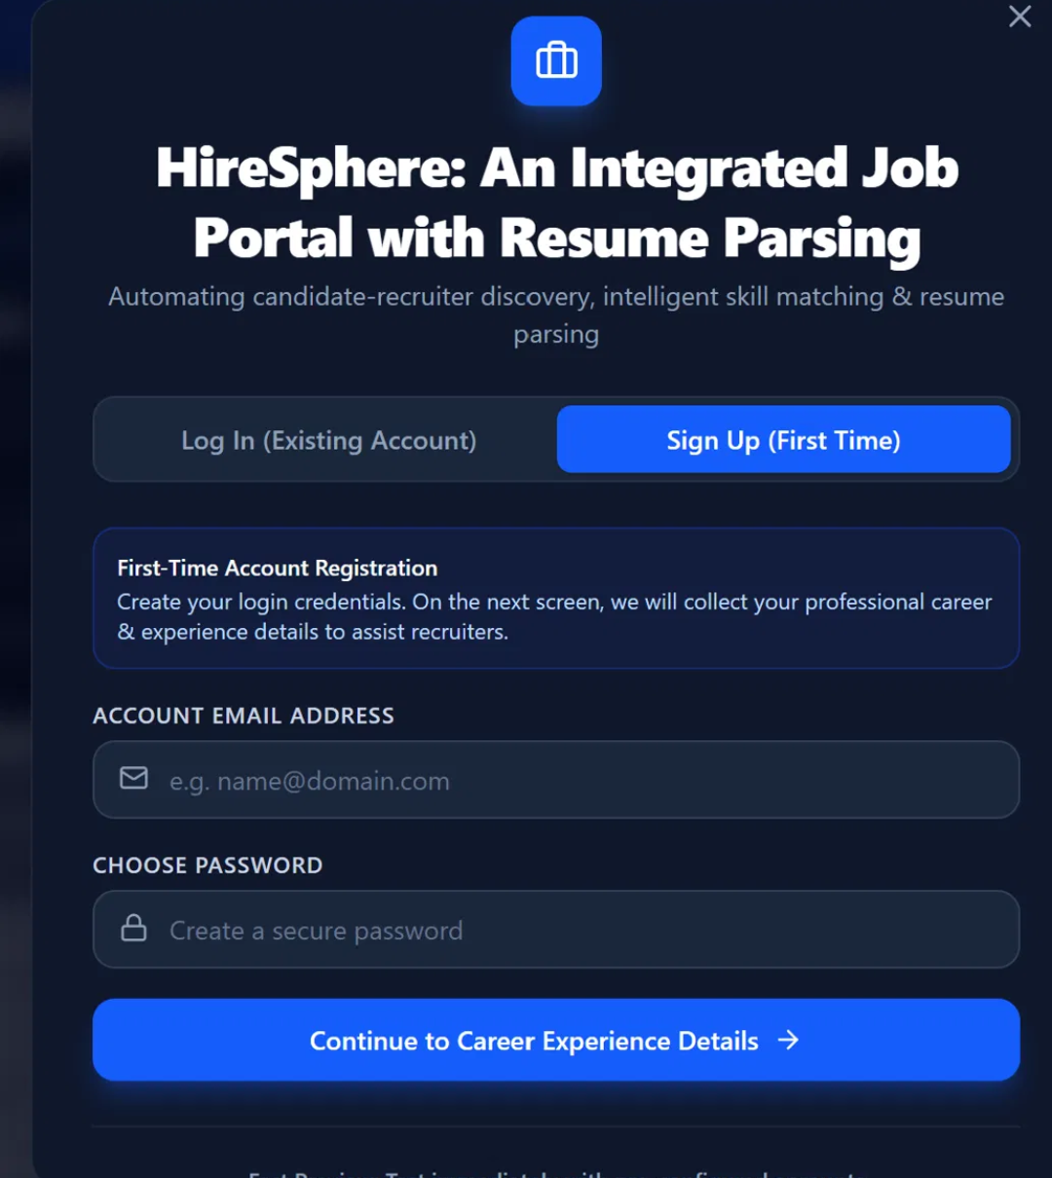
2. Job Search page with match scores
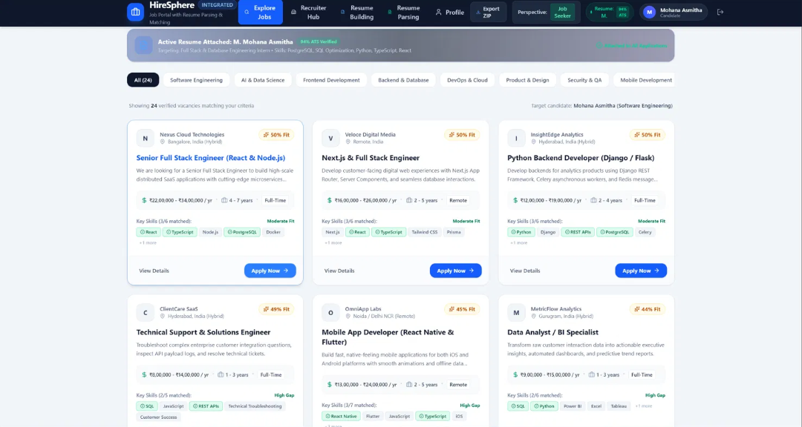
3. Apply dialog showing the candidate evaluation
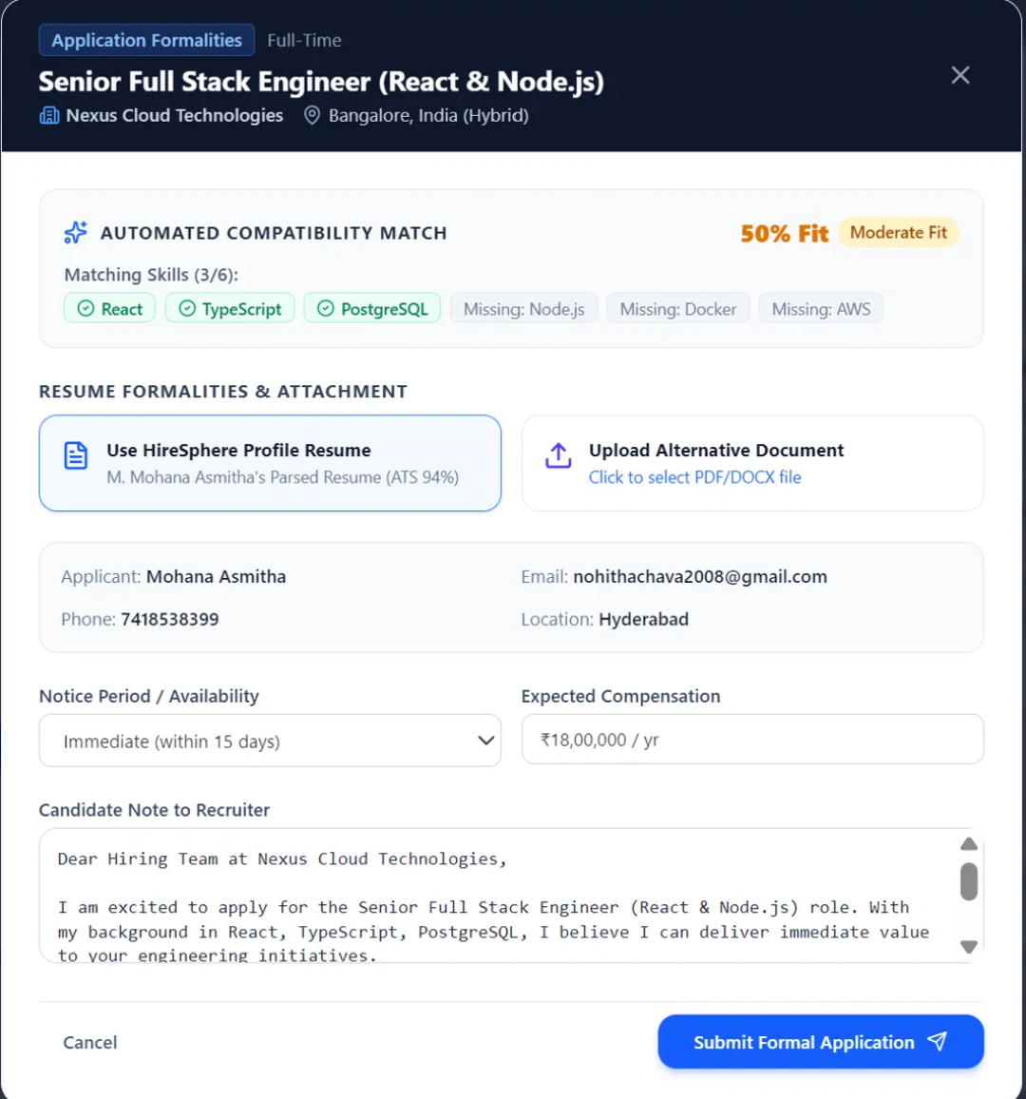
4. Recruiter Portal – applications ranked by match score
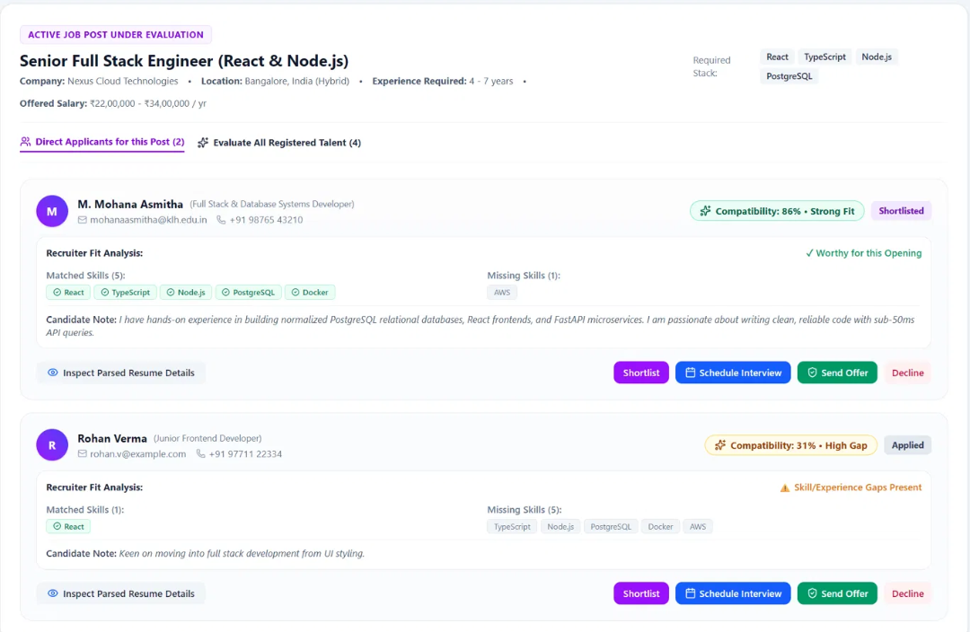
6. Resume Parser – parsed result with ATS score and audit
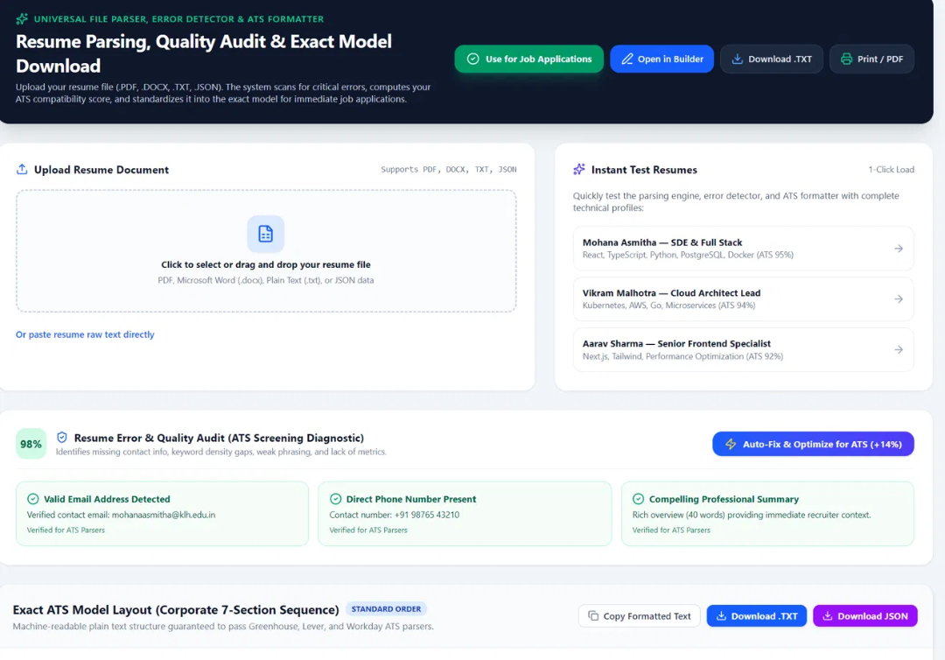
7. Resume Builder with live ATS audit
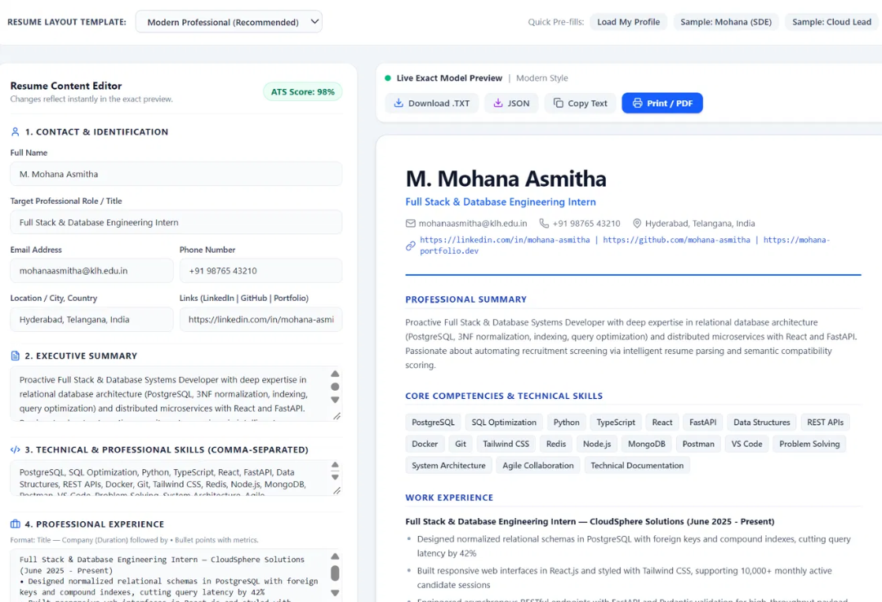
8. Profile page
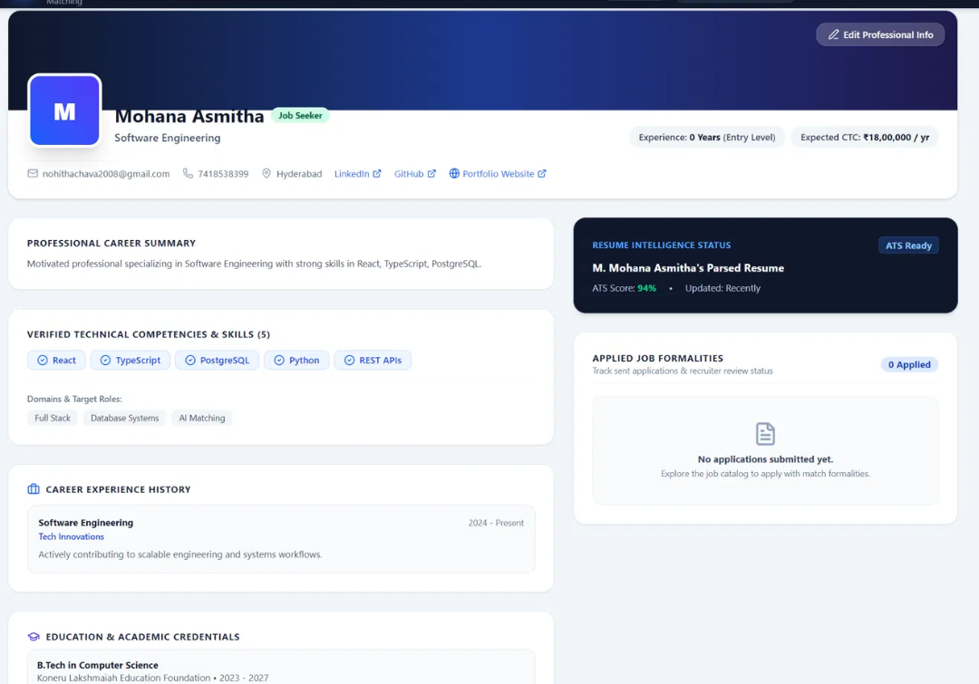

Appendix F: Database (SQL) and Backend Screenshots
Insert screenshots of the database and the running backend here. The grey line under each heading is the command or request that produces the screenshot.
F.1 Database (SQL) screenshots
F.1.2. Schema of users, jobs and applications (PRIMARY KEY, UNIQUE, indexes)
sqlite3 hiresphere.db ".schema"
